**LOGISTIC REGRESSION: Bank_Personal_Loan_modelling**

#import pandas

import pandas as pd

#Load dataset

dataset=pd.read_excel("Bank_Personal_Loan_Modelling.xlsx",sheet_name=1)

#checking for null values

print(dataset.isna().sum())

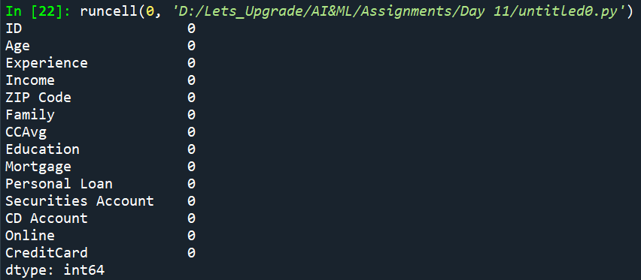

#removing unimportant columns

dataset=dataset.drop('ID',axis=1)

dataset=dataset.drop('ZIP Code',axis=1)

#declaring dependent variable

y=dataset['Personal Loan']

#declaring independent variable

x=dataset[['Age','Experience','Income','Family','CCAvg','Education','Mortgage','Securities Account','CD Account','Online','CreditCard']]

#import statsmodels package to apply Logistic Regression

import statsmodels.api as sm

#adding constant to the independent variables

x1=sm.add_constant(x)

#perform Logistic regression

Logistic=sm.Logit(y,x1)

#developing the model

result=Logistic.fit()

#viewing the result

print(result.summary())

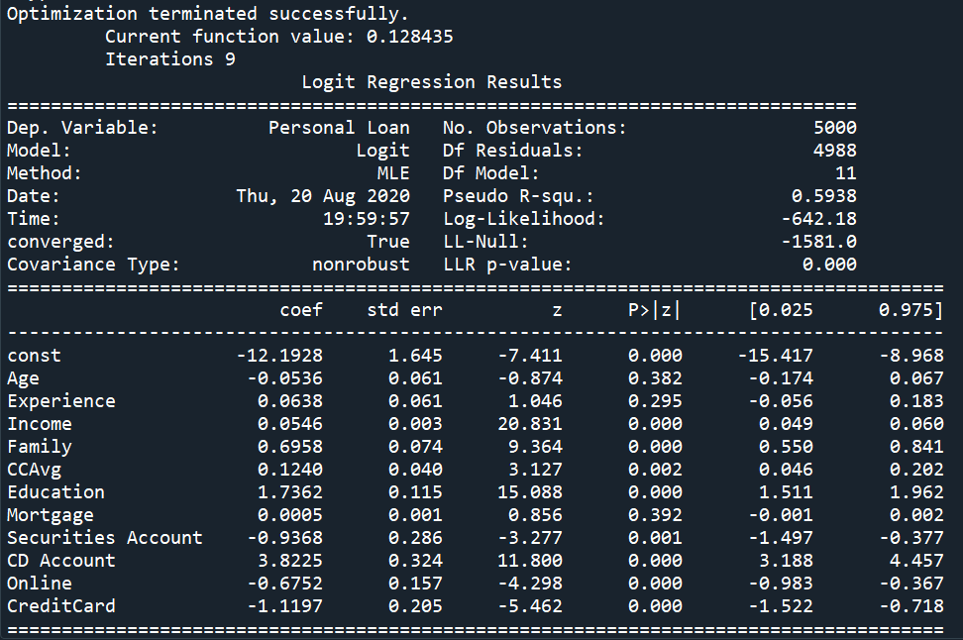

['Age','Experience','Income','Family','CCAvg','Education','Mortgage','Securities Account','CD Account','Online','CreditCard'] => All the independent variables have P<0.05. Therefore all the variables are significantly important.

**LOGISTIC REGRESSION: Attrition Analysis**

#import packages

import pandas as pd

import numpy as np

from sklearn import preprocessing

#load dataset

dataset=pd.read_csv("general_data.csv")

#drop unimportant columns

dataset=dataset.drop('EmployeeCount',axis=1)

dataset=dataset.drop('EmployeeID',axis=1)

dataset=dataset.drop('Over18',axis=1)

dataset=dataset.drop('StandardHours',axis=1)

dataset.info()

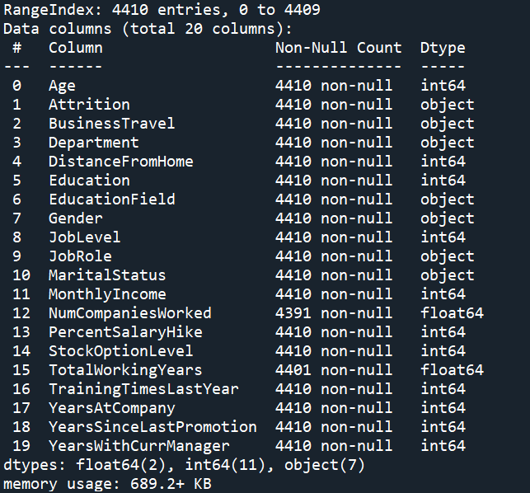

#converting string variables into Numerical

le=preprocessing.LabelEncoder()

le.fit(dataset["Gender"])

dataset["Gender"]=le.transform(dataset["Gender"])

le.fit(dataset["Attrition"])

dataset["Attrition"]=le.transform(dataset["Attrition"])

le.fit(dataset["BusinessTravel"])

dataset["BusinessTravel"]=le.transform(dataset["BusinessTravel"])

le.fit(dataset["Department"])

dataset["Department"]=le.transform(dataset["Department"])

le.fit(dataset["EducationField"])

dataset["EducationField"]=le.transform(dataset["EducationField"])

le.fit(dataset["JobRole"])

dataset["JobRole"]=le.transform(dataset["JobRole"])

le.fit(dataset["MaritalStatus"])

dataset["MaritalStatus"]=le.transform(dataset["MaritalStatus"])

le.fit(dataset["MaritalStatus"])

dataset["MaritalStatus"]=le.transform(dataset["MaritalStatus"])

#checking for null values

print(dataset.isna().sum())

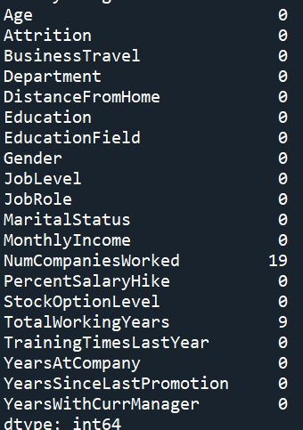

#replacing null values with average of variable

print("mean of NumCompaniesWorked: ",dataset["NumCompaniesWorked"].mean())

new_NCW_var=np.where(dataset["NumCompaniesWorked"].isnull(),2,dataset["NumCompaniesWorked"])

dataset["NumCompaniesWorked"]=new_NCW_var

print("mean of TotalWorkingYears: ",dataset["TotalWorkingYears"].mean())

new_TWY_var=np.where(dataset["TotalWorkingYears"].isnull(),11,dataset["TotalWorkingYears"])

dataset["TotalWorkingYears"]=new_TWY_var



#recheck for null values

print(dataset.isna().sum())

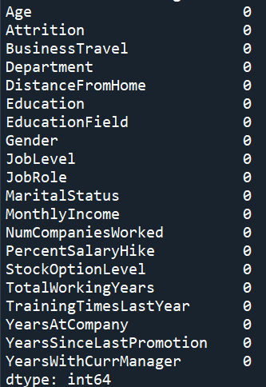

print(dataset.columns)

#declaring dependent variable

Y=dataset['Attrition']

#declaring independent variable

X=dataset[['Age','BusinessTravel','Department','DistanceFromHome','Education','EducationField', 'Gender', 'JobLevel', 'JobRole','MaritalStatus','MonthlyIncome','NumCompaniesWorked','PercentSalaryHike', 'StockOptionLevel', 'TotalWorkingYears','TrainingTimesLastYear', 'YearsAtCompany', 'YearsSinceLastPromotion','YearsWithCurrManager']]

#import statsmodels package to apply Logistic Regression

import statsmodels.api as sm

#adding constant to the independent variables

X1=sm.add_constant(X)

#perform Logistic regression

Logistic=sm.Logit(Y,X1)

#developing the model

result=Logistic.fit()

#viewing the result

print(result.summary())

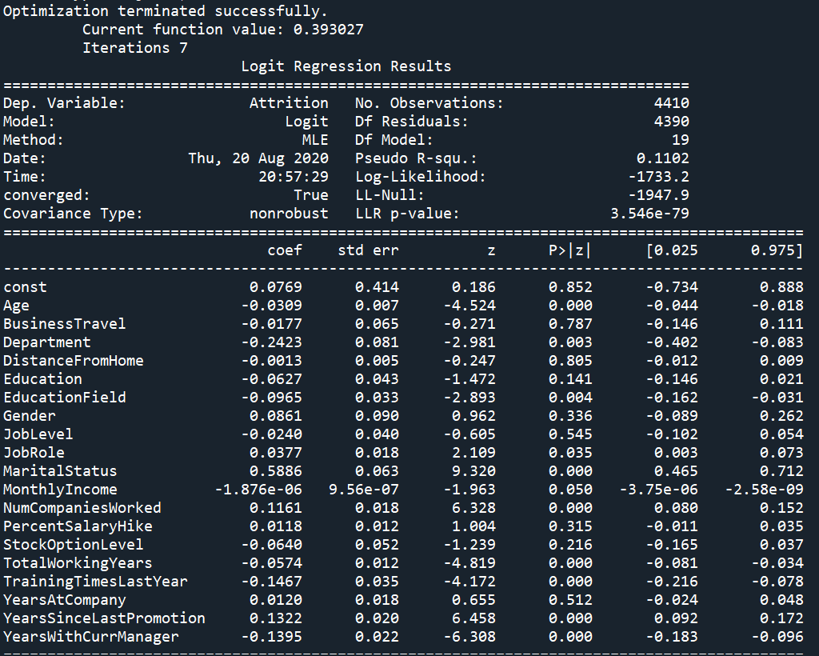

Age, Department, EducationField, JobeRole, MaritialStatus, Monthly Income, NumCompaniesWorked, TotalWorkingYears, TrainingTimesLastYear, YearsSinceLastPromotion, YearsWithCurrManager => P<0.05. Therefore, the variables are significantly important.

BusinessTravel, DistanceFromHome, Education, Gender, JobLevel, PercentSalaryHike, StockOptionLevel, YearsAtCompany => P>0.05. Therefore, the variables are not significantly important.

**LINEAR REGRESSION: price v\s sqft_living**

#Import numpy as np, pandas as pd,matplotlib.pyplot as plt and seaborn as sns.

import numpy as np

import pandas as pd

import matplotlib.pyplot as plt

import seaborn as sns

#Import the data using pandas

data=pd.read_excel("Linear Regression.xlsx",sheet_name=0)

#dropping unimportant columns

data=data.drop('bedrooms',axis=1)

data=data.drop('bathrooms',axis=1)

data=data.drop('floors',axis=1)

print(data.head())

print()

print(data.dtypes)

print()

#EXploratory Data Analysis-EDA

data.hist()

print(data.corr())

sns.scatterplot(data['sqft_living'],data['price'])

#assign features to X and Y

X=data.iloc[:,1:]

Y=data.iloc[:,:1]

#visualize dataset

plt.scatter(X,Y)

plt.title('price v/s sqft_living')

plt.xlabel('sqft_living')

plt.ylabel('price')

plt.show()

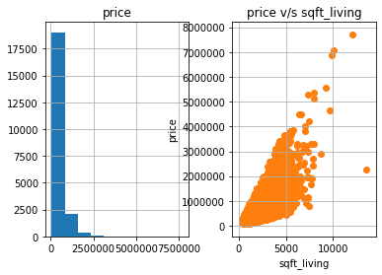

#split records for training and testing

from sklearn.model_selection import train_test_split

X_train,X_test,Y_train,Y_test=train_test_split(X,Y,test_size=0.2,random_state=0)

print(X_train.shape)

print(X_test.shape)

#model building with sklearn

from sklearn.linear_model import LinearRegression

lin_reg=LinearRegression()

#train the model

lin_reg.fit(X_train,Y_train)

print(lin_reg.coef_)

print(lin_reg.intercept_)

#visualize training set result

plt.scatter(X_train,Y_train,color='red')

plt.plot(X_train,lin_reg.predict(X_train),color='green')

plt.title('Linear Regression price v/s sqft_living(training set)')

plt.xlabel('sqft_living')

plt.ylabel('price')

plt.show()

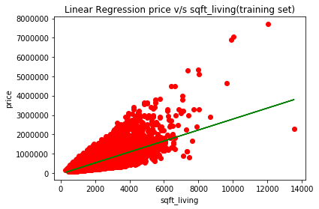

#test the model(for X_test value predict y value)

y_pred=lin_reg.predict(X_test)

print(y_pred)

print(X_test.head())

#compare initial data to predicted data

print(data.head())

#vizualise the test dataset

plt.scatter(X_test,Y_test,color='green')

plt.plot(X_test,lin_reg.predict(X_test),color='blue')

plt.title('Linear Regression price v/s sqft_living(testing set)')

plt.xlabel('sqft_living')

plt.ylabel('price')

plt.show()

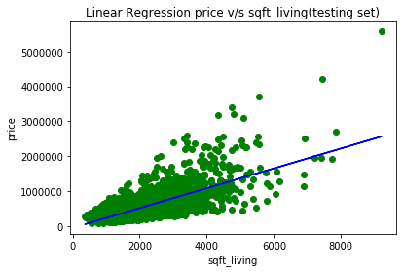

#Estimate the cost

from sklearn.metrics import mean_squared_error,r2_score

RSME=np.sqrt(mean_squared_error(Y_test, y_pred))

r_square=r2_score(Y_test, y_pred)

print("R square is the deciding factor - how much IDV affects DV:",r_square,"RSME value: ",RSME)

#predicting unseen value

unseen_predict=lin_reg.predict(np.array([[1060]]))

print("predicted value is: ",unseen_predict)

**Output:**

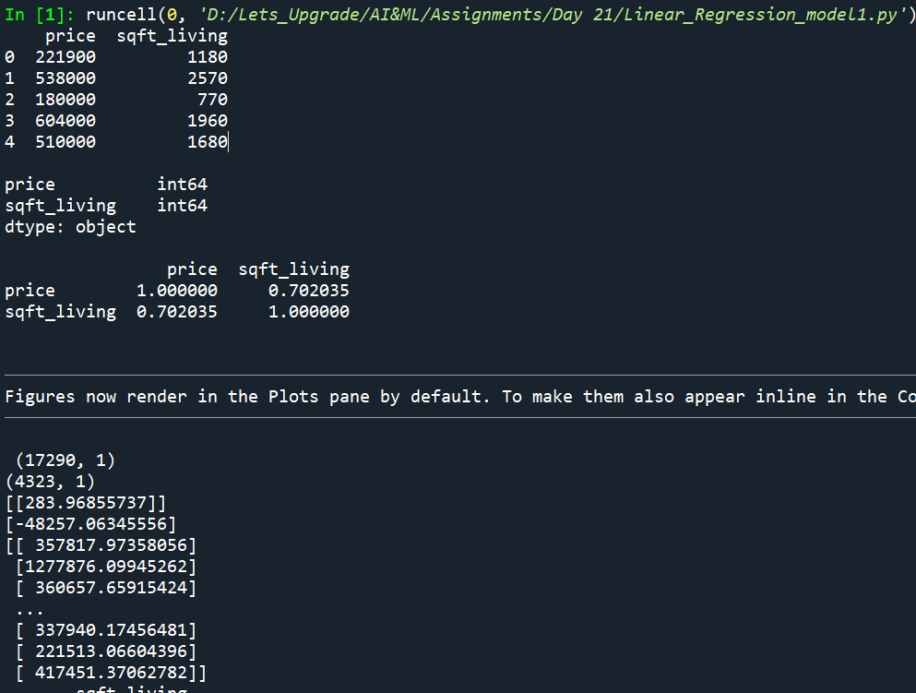 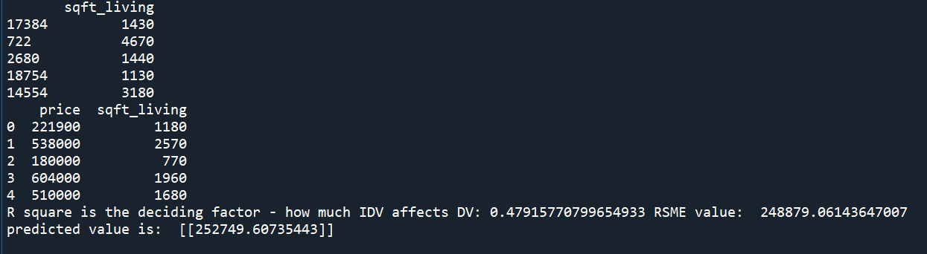

**LINEAR REGRESSION: price v\s bedrooms**

#Import numpy as np, pandas as pd,matplotlib.pyplot as plt and seaborn as sns.

import numpy as np

import pandas as pd

import matplotlib.pyplot as plt

import seaborn as sns

#Import the data using pandas

data=pd.read_excel("Linear Regression.xlsx",sheet_name=0)

#dropping unimportant columns

data=data.drop('sqft_living',axis=1)

data=data.drop('bathrooms',axis=1)

data=data.drop('floors',axis=1)

print(data.head())

print()

print(data.dtypes)

print()

#EXploratory Data Analysis-EDA

data.hist()

print(data.corr())

sns.scatterplot(data['bedrooms'],data['price'])

#assign features to X and Y

X=data.iloc[:,1:]

Y=data.iloc[:,:1]

#visualize dataset

plt.scatter(X,Y)

plt.title('price v/s bedrooms')

plt.xlabel('bedrooms')

plt.ylabel('price')

plt.show()

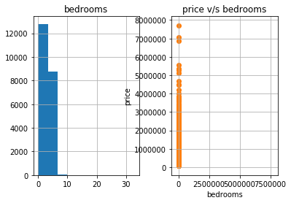

#split records for training and testing

from sklearn.model_selection import train_test_split

X_train,X_test,Y_train,Y_test=train_test_split(X,Y,test_size=0.2,random_state=0)

print(X_train.shape)

print(X_test.shape)

#model building with sklearn

from sklearn.linear_model import LinearRegression

lin_reg=LinearRegression()

#train the model

lin_reg.fit(X_train,Y_train)

print(lin_reg.coef_)

print(lin_reg.intercept_)

#visualize training set result

plt.scatter(X_train,Y_train,color='red')

plt.plot(X_train,lin_reg.predict(X_train),color='green')

plt.title('Linear Regression price v/s bedrooms(training set)')

plt.xlabel('bedrooms')

plt.ylabel('price')

plt.show()

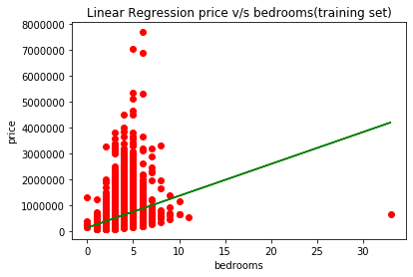

#test the model(for X_test value predict y value)

y_pred=lin_reg.predict(X_test)

print(y_pred)

print(X_test.head())

#compare initial data to predicted data

print(data.head())

#vizualise the test dataset

plt.scatter(X_test,Y_test,color='green')

plt.plot(X_test,lin_reg.predict(X_test),color='blue')

plt.title('Linear Regression price v/s bedrooms(testing set)')

plt.xlabel('bedrooms')

plt.ylabel('price')

plt.show()

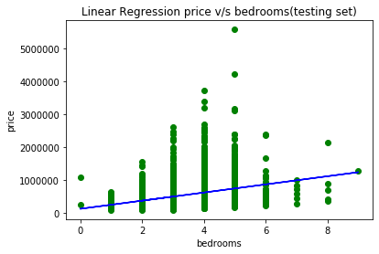

#Estimate the cost

from sklearn.metrics import mean_squared_error,r2_score

RSME=np.sqrt(mean_squared_error(Y_test, y_pred))

r_square=r2_score(Y_test, y_pred)

print("R square is the deciding factor - how much IDV affects DV:",r_square,"RSME value: ",RSME)

#predicting unseen value

unseen_predict=lin_reg.predict(np.array([[10]]))

print("predicted value is: ",unseen_predict)

**Output:**

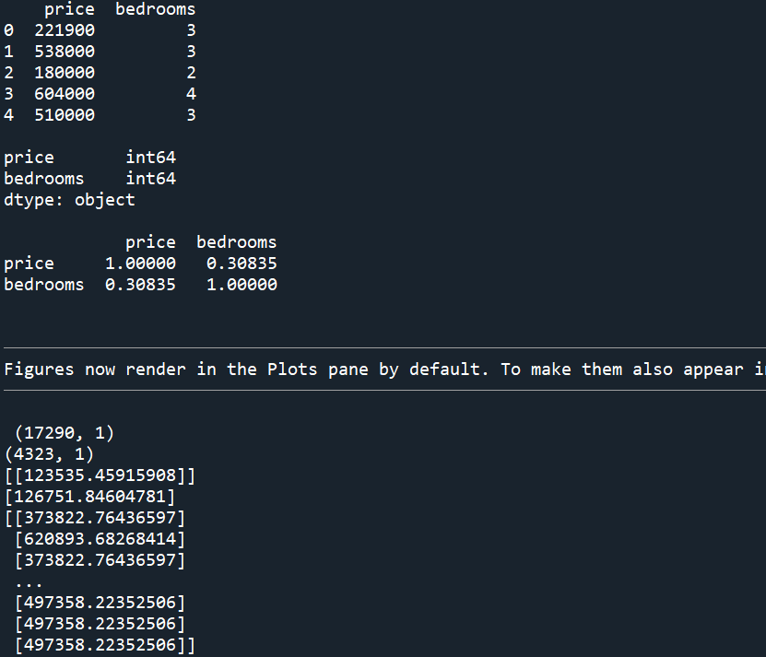 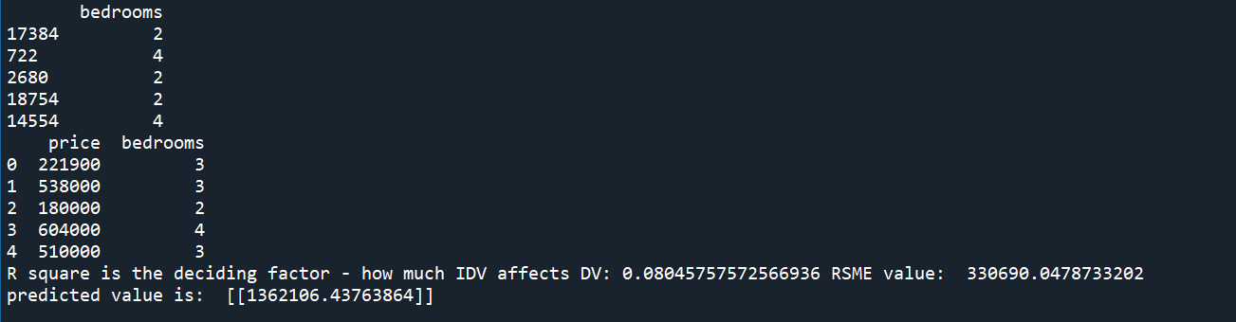

**LINEAR REGRESSION: price v\s bathrooms**

#Import numpy as np, pandas as pd,matplotlib.pyplot as plt and seaborn as sns.

import numpy as np

import pandas as pd

import matplotlib.pyplot as plt

import seaborn as sns

#Import the data using pandas

data=pd.read_excel("Linear Regression.xlsx",sheet_name=0)

#dropping unimportant columns

data=data.drop('sqft_living',axis=1)

data=data.drop('bedrooms',axis=1)

data=data.drop('floors',axis=1)

print(data.head())

print()

print(data.dtypes)

print()

#EXploratory Data Analysis-EDA

data.hist()

print(data.corr())

sns.scatterplot(data['bathrooms'],data['price'])

#assign features to X and Y

X=data.iloc[:,1:]

Y=data.iloc[:,:1]

#visualize dataset

plt.scatter(X,Y)

plt.title('price v/s bathrooms')

plt.xlabel('bathrooms')

plt.ylabel('price')

plt.show()

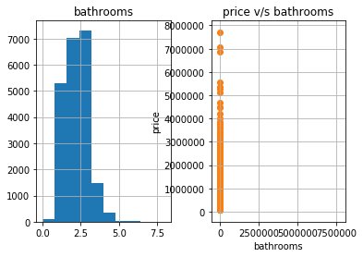

#split records for training and testing

from sklearn.model_selection import train_test_split

X_train,X_test,Y_train,Y_test=train_test_split(X,Y,test_size=0.2,random_state=0)

print(X_train.shape)

print(X_test.shape)

#model building with sklearn

from sklearn.linear_model import LinearRegression

lin_reg=LinearRegression()

#train the model

lin_reg.fit(X_train,Y_train)

print(lin_reg.coef_)

print(lin_reg.intercept_)

#visualize training set result

plt.scatter(X_train,Y_train,color='red')

plt.plot(X_train,lin_reg.predict(X_train),color='green')

plt.title('Linear Regression price v/s bathrooms(training set)')

plt.xlabel('bathrooms')

plt.ylabel('price')

plt.show()

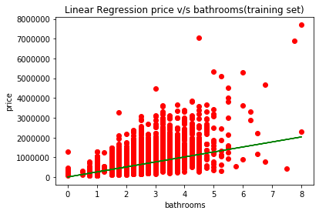

#test the model(for X_test value predict y value)

y_pred=lin_reg.predict(X_test)

print(y_pred)

print(X_test.head())

#compare initial data to predicted data

print(data.head())

#vizualise the test dataset

plt.scatter(X_test,Y_test,color='green')

plt.plot(X_test,lin_reg.predict(X_test),color='blue')

plt.title('Linear Regression price v/s bathrooms(testing set)')

plt.xlabel('bathrooms')

plt.ylabel('price')

plt.show()

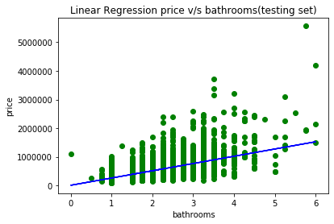

#Estimate the cost

from sklearn.metrics import mean_squared_error,r2_score

RSME=np.sqrt(mean_squared_error(Y_test, y_pred))

r_square=r2_score(Y_test, y_pred)

print("R square is the deciding factor - how much IDV affects DV:",r_square,"RSME value: ",RSME)

#predicting unseen value

unseen_predict=lin_reg.predict(np.array([[2.25]]))

print("predicted value is: ",unseen_predict)

**Output:**

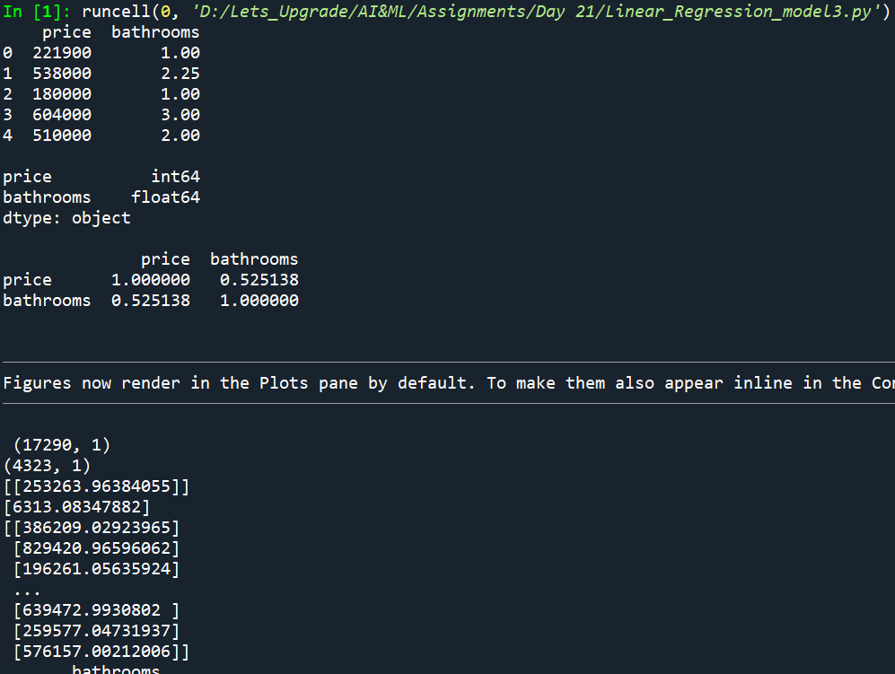 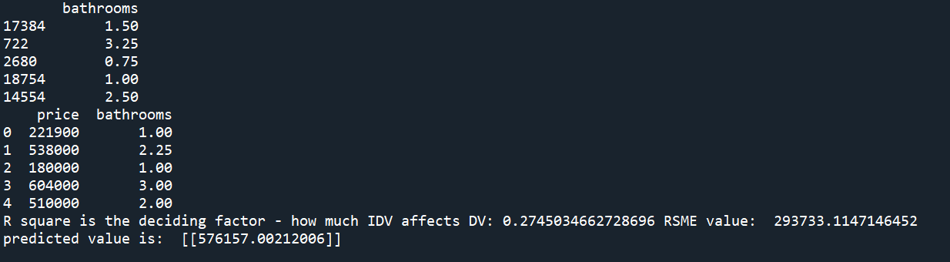

**LINEAR REGRESSION: price v\s floors**

#Import numpy as np, pandas as pd,matplotlib.pyplot as plt and seaborn as sns.

import numpy as np

import pandas as pd

import matplotlib.pyplot as plt

import seaborn as sns

#Import the data using pandas

data=pd.read_excel("Linear Regression.xlsx",sheet_name=0)

#dropping unimportant columns

data=data.drop('sqft_living',axis=1)

data=data.drop('bedrooms',axis=1)

data=data.drop('bathrooms',axis=1)

print(data.head())

print()

print(data.dtypes)

print()

#EXploratory Data Analysis-EDA

data.hist()

print(data.corr())

sns.scatterplot(data['floors'],data['price'])

#assign features to X and Y

X=data.iloc[:,1:]

Y=data.iloc[:,:1]

#visualize dataset

plt.scatter(X,Y)

plt.title('price v/s floors')

plt.xlabel('floors')

plt.ylabel('price')

plt.show()

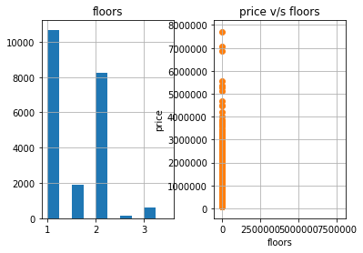

#split records for training and testing

from sklearn.model_selection import train_test_split

X_train,X_test,Y_train,Y_test=train_test_split(X,Y,test_size=0.2,random_state=0)

print(X_train.shape)

print(X_test.shape)

#model building with sklearn

from sklearn.linear_model import LinearRegression

lin_reg=LinearRegression()

#train the model

lin_reg.fit(X_train,Y_train)

print(lin_reg.coef_)

print(lin_reg.intercept_)

#visualize training set result

plt.scatter(X_train,Y_train,color='red')

plt.plot(X_train,lin_reg.predict(X_train),color='green')

plt.title('Linear Regression price v/s floors(training set)')

plt.xlabel('floors')

plt.ylabel('price')

plt.show()

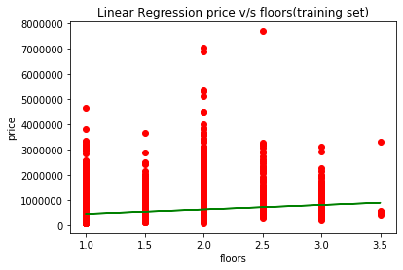

#test the model(for X_test value predict y value)

y_pred=lin_reg.predict(X_test)

print(y_pred)

print(X_test.head())

#compare initial data to predicted data

print(data.head())

#vizualise the test dataset

plt.scatter(X_test,Y_test,color='green')

plt.plot(X_test,lin_reg.predict(X_test),color='blue')

plt.title('Linear Regression price v/s floors(testing set)')

plt.xlabel('floors')

plt.ylabel('price')

plt.show()

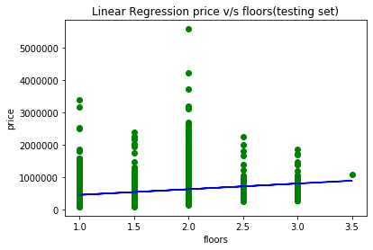

#Estimate the cost

from sklearn.metrics import mean_squared_error,r2_score

RSME=np.sqrt(mean_squared_error(Y_test, y_pred))

r_square=r2_score(Y_test, y_pred)

print("R square is the deciding factor - how much IDV affects DV:",r_square,"RSME value: ",RSME)

#predicting unseen value

unseen_predict=lin_reg.predict(np.array([[2.25]]))

print("predicted value is: ",unseen_predict)

**Output:**

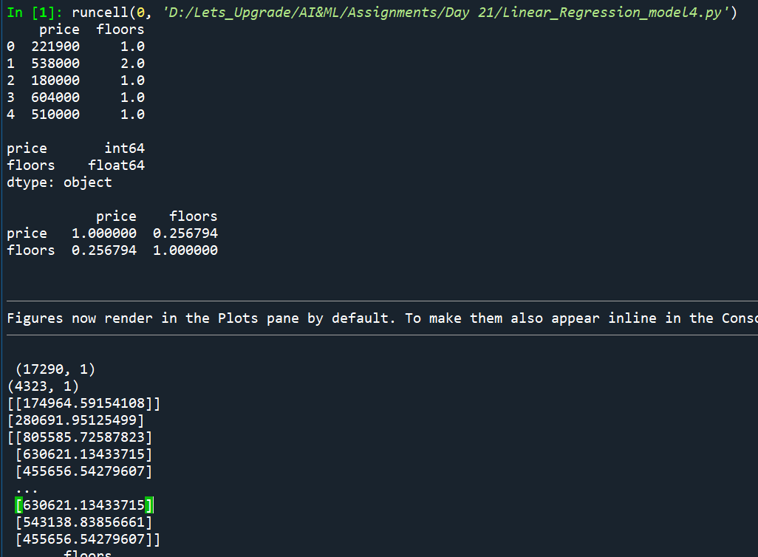 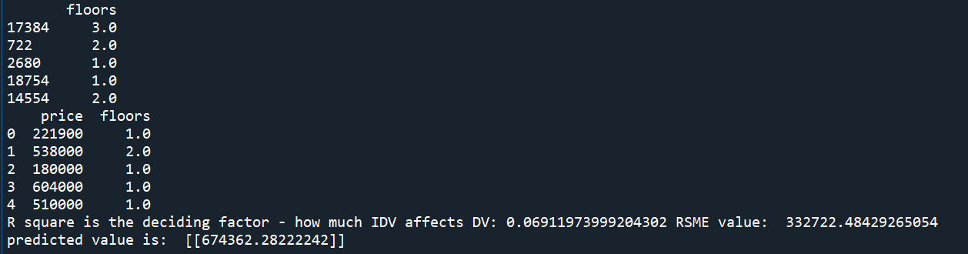

**MULTIPLE LINEAR REGRESSION: (DV🡪price) v\s (IDV🡪sqft_living, bedrooms, bathrooms, floors)**

#import packages for Multiple Linear Regression

import numpy as np

import pandas as pd

import matplotlib.pyplot as plt

import seaborn as sns

#load data

data=pd.read_excel("Linear Regression.xlsx",sheet_name=0)

#check for string value

print(data.dtypes)

#check for null values in dataset

print(data.isnull().sum())

print(data.describe())

data.hist()

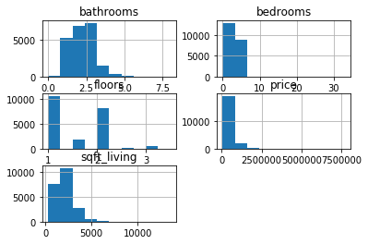

#data normalization(not required as no bid diff in data values)

#from sklearn.preprocessing import StandardScaler

#sc=StandardScaler()

#data=sc.fit_transform(data)

#before splitting assign input variables(IDV) to X and output variable(DV) to Y

X=data.iloc[:,1:5]

Y=data.iloc[:,:1]

#split records for training and testing in ration 75:25

from sklearn.model_selection import train_test_split

x_train,x_test,y_train,y_test=train_test_split(X,Y,test_size=0.25,random_state=2)

#training the model by calling linear regression algorithm from sklearn

from sklearn.linear_model import LinearRegression

mul_reg=LinearRegression()

mul_reg.fit(x_train,y_train)

#testing the model

ypred=mul_reg.predict(x_test)

#forecasting by trained data

unseen_pred=mul_reg.predict(np.array([[1180,3,1,1]]))

print(unseen_pred)

#evaluation

from sklearn.metrics import r2_score,mean_squared_error

RSME=np.sqrt(mean_squared_error(y_test, ypred))

r_square=r2_score(y_test, ypred)

print("R square is the deciding factor - how much IDV affects DV:",r_square,"RSME value: ",RSME)

#inferences

print(data.corr())

sns.pairplot(data)

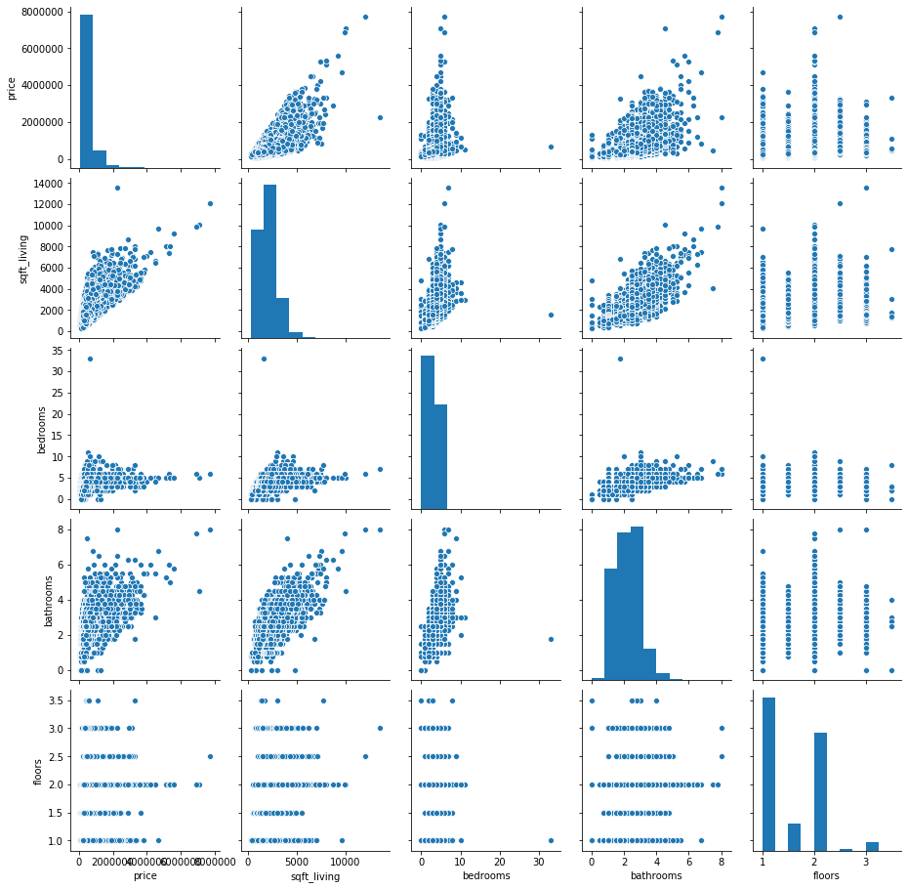

**Output:**

